

**A PROJECT REPORT ON**

**Project Title**

**SUBMITTED TO**

**St. Mira’s College for Girls, Pune**

**Autonomous (Affiliated to Savitribai Phule Pune University)**

**UNDER THE GUIDANCE OF**

**Mrs . SMITA BORKAR**

**FOR THE PARTIAL FULFILLMENT OF**

**BACHELOR OF COMPUTER SCIENCE**

**(T. Y. B.Sc. 2023-24)**

**BY:**

**MS. Aishwarya Kamble (5651/S221002)**

**YEAR: 2024-25**

**SADHU VASWANI MISSION’S**

**St. Mira’s College for Girls, Pune**



**Autonomous (Affiliated to Savitribai Phule Pune University)**

**Reaccredited by NAAC- A Grade, cycle 3**

**[ARTS, COMMERCE, SCIENCE, BSc(Computer Science), BBA, BBA(CA)]**

**6, Koregaon Road, Pune-411001. [INDIA]**

CERTIFICATE

This is to certify that **Aishwarya Kamble** **(5651/S221002)**

has successfully completed her Project titled **ONLINE MOVIE TICKET BOOKING SYSTEM**. The same constitutes a part of T.Y.B.Sc. (Comp. Sci.) curriculum for the academic year :2024-2025.

----------------------- ---------------------------- ----------------------

Internal Examiner Course Coordinator External Examiner

----------------------- --------------------------- ----------------------

Project Guide Student Sign Student Sign

|  |  |
| --- | --- |
| **SR.NO** | **CONTENT** |
| **1** | **Abstract** |
| **2** | **Introduction**  • Benefits  • Problem statement  • Purpose/objective and goals  • Literature survey  • Project scope and limitations |
| **3** | **System analysis**  • Existing systems  • Scope and limitations of existing systems  • Project perspective, features  • Stakeholders  • Requirement analysis :Functional requirements, Non-functional requirements, Performance requirements etc. |
| **4** | **System Design**  • Design constraints  • Data Model  • User interfaces |
| **5** | **Implementation details**  • Software/hardware specification |
| **6** | **Outputs and Reports Testing**  Test Plan, Black Box Testing, White Box Testing |
| **7** | **Conclusion and Recommendations** |
| **8** | **Future Scope** |
| **9** | **Bibliography** |

PROJECT INDEX

**ABSTRACT**

The **Online Movie Ticket Booking System** is a web-based application designed to provide users with a seamless and efficient way to book movie tickets online. This system eliminates the need for physical ticket counters and long queues, offering users a convenient and hassle-free experience.

The project is built using **PHP, HTML, CSS, JavaScript, and MySQL**, running on the **WAMP server**. Users can register, log in, and select their preferred **movie, show timing, and seats** through an interactive interface

This project provides an efficient and user-friendly experience with an **attractive UI**, **graphical seat selection**, and **ticket confirmation pages**, making online movie ticket booking both simple and enjoyable.

**MOTIVATION**

The **Online Movie Ticket Booking System** was developed to address the inefficiencies of traditional movie ticket booking methods. Long queues, limited ticket availability at counters, and lack of real-time booking status often cause inconvenience for users. This project aims to provide a **user-friendly, efficient, and secure platform** where users can book movie tickets from the comfort of their homes.

With the rise of digital platforms, online ticket booking has become an essential service. Our system is designed to streamline the process, allowing users to **register, log in, select movies, choose seats visually, and receive booking confirmations instantly**.

Additionally, an **Admin Panel** has been integrated to help administrators manage **user bookings, seat availability, and booking records** efficiently. By leveraging **PHP, HTML, CSS, JavaScript, and MySQL**, the system ensures a **seamless experience** for both users and administrators.

This project was developed with the goal of enhancing **user convenience, reducing manual work, and improving the overall movie-going experience** through technology.

**PROBLEM STATEMENT**

In traditional movie ticket booking methods, customers often face several challenges, such as **long queues, limited seat availability, manual errors in bookings, and lack of real-time updates**. The absence of an efficient system can lead to confusion, delays, and inconvenience for both users and theater administrators.

The **Online Movie Ticket Booking System** aims to solve these issues by providing a **digital platform where users can book tickets easily**. The system allows users to:

* **Register and log in securely**
* **Browse available movies and showtimes**
* **Select seats through a visual interface**
* **Confirm bookings and receive a digital ticket**
* **View booking history**

Additionally, an **Admin Panel** has been implemented to allow administrators to **manage user bookings, track seat availability, and monitor overall system activity**.

By developing this system, we aim to **eliminate manual booking inefficiencies, enhance user convenience, and provide a seamless movie ticket booking experience**.

**OBJECTIVES AND GOALS**

**Objectives:**

The **Online Movie Ticket Booking System** is designed to provide a seamless and efficient way for users to book movie tickets online while ensuring smooth management for administrators. The key objectives of the system are:

1. **User-Friendly Booking Process** – Enable users to easily browse movies, select showtimes, and reserve seats through an interactive interface.
2. **Visual Seat Selection** – Provide a graphical representation of theater seating for users to choose their preferred seats.
3. **Secure User Authentication** – Implement a login and registration system to maintain user accounts and booking history.
4. **Admin Management Panel** – Allow administrators to manage theaters, movies, show timings, and user bookings effectively.
5. **Real-Time Seat Availability** – Ensure that seat selection updates dynamically to avoid double bookings.
6. **Booking Confirmation & Digital Tickets** – Generate an electronic ticket after successful booking, displaying all necessary details.
7. **Efficient Data Handling** – Store user bookings, seat selections, and movie details in a structured database for smooth operations.

**Goals:**

The primary goals of this project are:

1. **To develop a fully functional online movie ticket booking system** that eliminates the need for physical ticket purchases.
2. **To enhance the user experience** by providing a visually appealing and easy-to-navigate interface.
3. **To ensure data accuracy and consistency** by maintaining a well-organized database for bookings and user information.
4. **To improve administrative efficiency** by enabling real-time monitoring of user activity and seat reservations.
5. **To create a reliable system with minimal errors**, ensuring seamless booking without discrepancies.
6. **To provide future scalability**, allowing easy integration of additional features like payment gateways if required.

By achieving these objectives and goals, the system will ensure a **hassle-free, efficient, and enjoyable movie ticket booking experience** for users while simplifying theater management for administrators.

**LITERATURE SURVEY**

The **Online Movie Ticket Booking System** has evolved from traditional manual booking to digital platforms that offer convenience, real-time seat selection, and user authentication.

Existing platforms like **BookMyShow** and **Paytm Movies** provide features like **movie selection, seat reservation, payment integration, and booking confirmation**. However, they have drawbacks, such as **high convenience fees, dependence on internet connectivity, and limited admin control**.

Research shows that **digital ticketing reduces wait times, improves customer experience, and enhances security** through session-based authentication.

This project improves upon existing systems by:  
✅ **Providing an admin panel** for real-time seat and booking management.  
✅ **Ensuring secure user authentication** to track bookings.  
✅ **Avoiding complex payment processes**, focusing only on seat reservations.

By addressing these gaps, the system **offers a user-friendly, efficient, and scalable movie booking experience** while giving **admins greater control** over theater operations.

**SCOPE AND LIMITATION**

**Scope**

The **Online Movie Ticket Booking System** aims to provide a seamless platform for users to book movie tickets with real-time seat selection and admin management.

✅ **User Features**:

* Register/Login to book tickets.
* Browse available movies and select preferred showtimes.
* Choose seats from a **graphical seating layout**.
* Receive booking confirmation with ticket details.

✅ **Admin Features**:

* Manage users and bookings.
* View real-time seat availability.
* Update movie schedules and theater details.

✅ **Other Functionalities**:

* Session-based authentication for secure booking.
* Well-structured and attractive UI for a better user experience.

**Limitations**

❌ **No Online Payment Module**: Users cannot make payments through the system; tickets are booked without online transactions.  
❌ **Limited Theater Selection**: Users can only book tickets for predefined theaters.  
❌ **Internet Dependency**: The system requires an internet connection for real-time booking and seat availability.  
❌ **No Mobile App**: The system is designed for web use only and is not available as a mobile application.  
❌ **Single-User Login at a Time**: No multi-session support for users logging in from multiple devices.

Despite these limitations, the system provides an **efficient and secure movie booking experience with essential features** while allowing future enhancements.

**SYSTEM ANALYSIS**

**EXISTING SYSTEM:**

The current movie ticket booking methods involve **manual booking at theater counters** or **third-party platforms**, both of which have drawbacks. **Manual booking** is time-consuming, prone to errors, and lacks real-time seat selection. **Third-party platforms** often charge extra fees and rely on external payment gateways, leading to potential transaction failures.

**Challenges in the Existing System:**

* Long queues and time-consuming processes.
* No real-time seat selection in manual booking.
* Lack of admin control over bookings.
* Security risks in third-party payment handling.

The **proposed system** overcomes these issues by providing an **efficient, user-friendly, and secure online platform** with **real-time seat selection, booking management, and an admin panel for better control**.

**SCOPE AND LIMITATIONS OF THE EXISTING SYSTEMS**

**Scope:**

* The current system allows **manual ticket booking** at theater counters or through **third-party platforms**.
* Users can select movies, theaters, and show timings, but seat selection is **not always available in real-time** for manual booking.
* Theaters manage ticket availability, pricing, and seat allocation without automated tracking.
* Third-party platforms provide an **online booking system** but charge additional fees and rely on **external payment gateways**.

**Limitations:**

* **No real-time seat selection** in manual booking, leading to confusion and inconvenience.
* **Long waiting times** at counters, especially for popular movies.
* **Limited admin control** over bookings and user management in third-party platforms.
* **Higher costs** due to additional fees charged by third-party booking platforms.
* **Security risks** in external payment handling.
* **No centralized database** for managing user details, bookings, and available seats.

**PROJECT PERSPECTIVE,FEATURES AND STAKEHOLDERS**

**Project Perspective**

The **Online Movie Ticket Booking System** is designed to provide a **hassle-free** and **efficient** way for users to book movie tickets. Unlike traditional booking systems that require **manual intervention**, this system offers **real-time seat selection, automated booking management, and an admin panel** for monitoring transactions. The project aims to **eliminate third-party dependencies**, giving theaters full control over their bookings and customer management.

**Key Features**

1. **User Authentication** – Secure login and registration using an email and password.
2. **Movie Selection** – Display of available movies with show timings, descriptions, and ratings.
3. **Seat Selection** – Graphical interface for selecting seats in real-time.
4. **Admin Panel** – Admins can manage bookings, view user details, and update movie schedules.
5. **Booking Confirmation** – Users receive a **digital ticket** with all booking details.
6. **Payment Handling** – Supports **cash on delivery** (since payment gateway integration is excluded).
7. **User Dashboard** – Users can view and manage their bookings.
8. **Responsive Design** – Optimized for both desktop and mobile devices.

**Stakeholders**

1. **Users (Customers)** – Individuals who book movie tickets through the system.
2. **Theater Owners/Admins** – Manage movie listings, monitor bookings, and handle seat availability.
3. **System Administrator** – Oversees the **entire platform**, ensuring data security and functionality.
4. **Developers** – Maintain and enhance the system based on **user feedback and requirements**.

The system provides **convenience, efficiency, and transparency**, benefiting all stakeholders involved.

**REQUIREMENT ANALYSIS - FUNCTIONAL REQUIREMENTS, PERFORMANCE REQUIREMENTS, SECURITY REQUIREMENTS ETC.**

**Requirement Analysis**

**1. Functional Requirements**

These define the core functionalities the system must provide:

* **User Management**:
  + User registration and login with email authentication.
  + Admin login to manage bookings and user details.
* **Movie and Show Management**:
  + Display available movies with details such as **title, duration, genre, and show timings**.
  + Allow admin to **add, update, or remove** movies from the system.
* **Seat Selection**:
  + Users can view and select available seats **graphically**.
  + Booked seats should be stored and unavailable for others.
* **Booking and Confirmation**:
  + Users can book tickets and receive **booking confirmation**.
  + Admin can monitor and manage **all bookings**.
* **Admin Panel**:
  + Manage **movies, bookings, and registered users**.
  + View transaction history and booking reports.

**2. Performance Requirements**

* The system should support **multiple concurrent users** without lag.
* **Real-time updates** for seat availability to prevent duplicate bookings.
* Pages should load within **2-3 seconds** for smooth user experience.
* The system should be scalable to accommodate future **movie listings and increased traffic**.

**3. Security Requirements**

* **User authentication and session management** to prevent unauthorized access.
* **Data encryption** (using MD5 for password hashing due to WAMP Server 5 limitations).
* Secure **database transactions** to prevent SQL injection attacks.
* **Restricted admin access** with authentication to protect sensitive data.

**DESIGN CONSTRAINTS**

1. Technology limitations

2. Budgetary constraints

3. Time constraints

4. Scalability requirements

5. Performance requirements

6. Security and compliance

7. User experience (UX) constraints

8. Integration constraints

9. Resource constraints

10. Regulatory and legal constraints.

**DATA MODEL**

**Database details –**

To store the related data, we have created a database named “movie_db”. In this database we have created many tables to store the data like user’s data, movie data, show timing, bookings, movie details etc.

**Schemas –**

1. User Schema –

users (id, name, email, password, mobile);

1. Movie Schema –

movies (id, name, description, link, logo);

1. Shows Schema –

shows (id, show_time);

1. Booking Schema –

booking (booking_id, booked_seats, user_id, movie_name, show_time, booking_time, is_cancel);

1. Admin Schema –

admins (id, name, email, password);

1. **Frontend:** HTML, CSS (for UI design and responsiveness)

**TECHNOLOGY USED**

1. **Backend:** PHP (for server-side logic and database interactions)
2. **Database:** MySQL (for storing user, resume, and job data)
3. **Server:** WAMP (Windows, Apache, MySQL, PHP) for local development
4. **Development Tools:** VS Code (for writing and managing code)
5. **Security Measures:** PHP session management, data validation, and SQL injection prevention

These technologies ensure a **dynamic, secure, and efficient** Resume Builder system.

MODULES

**Home Page:**

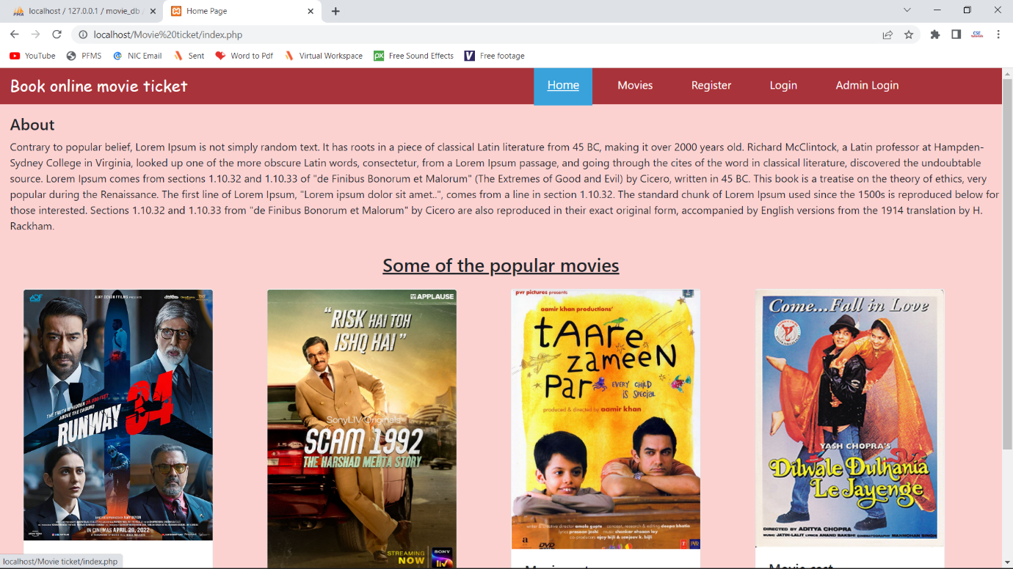

**Movies Page:**

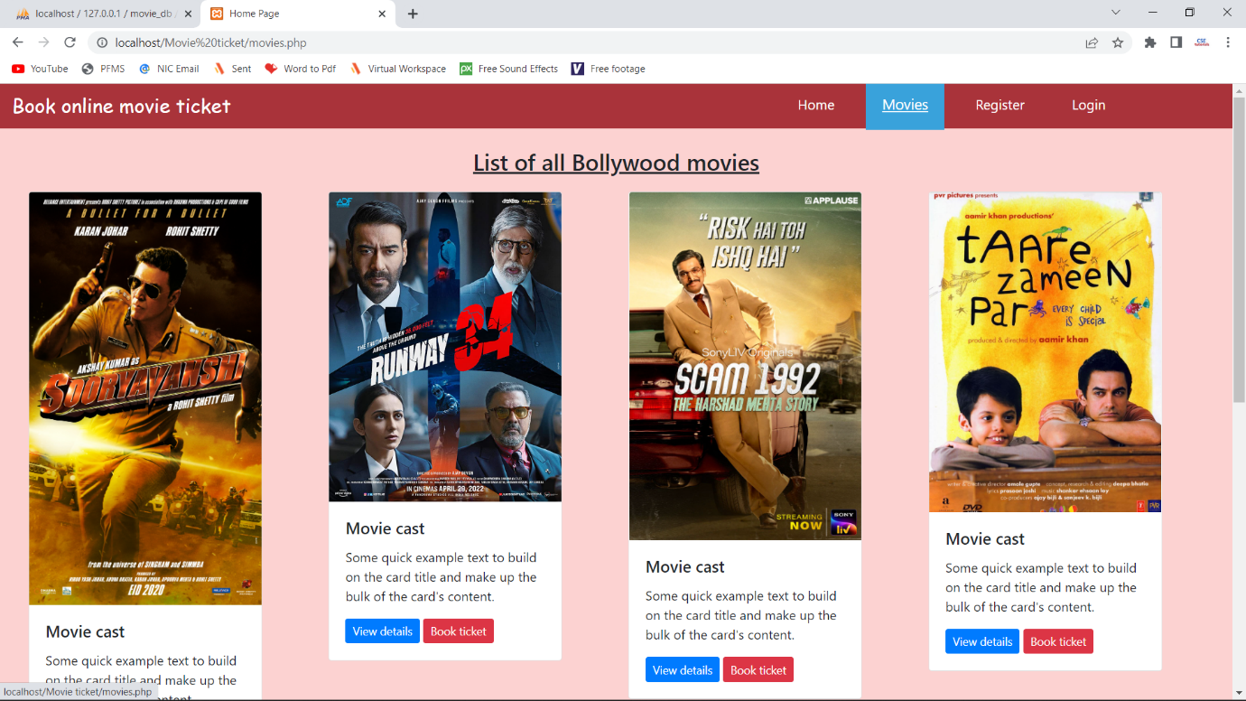

**Register Page :**

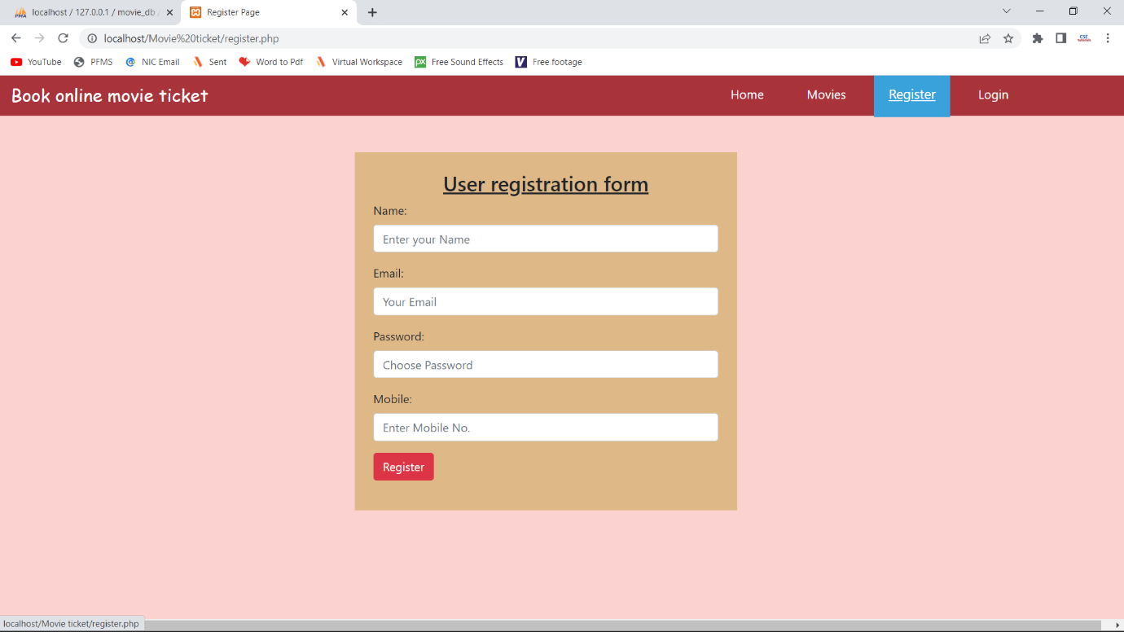

**User Dashboard Page :**

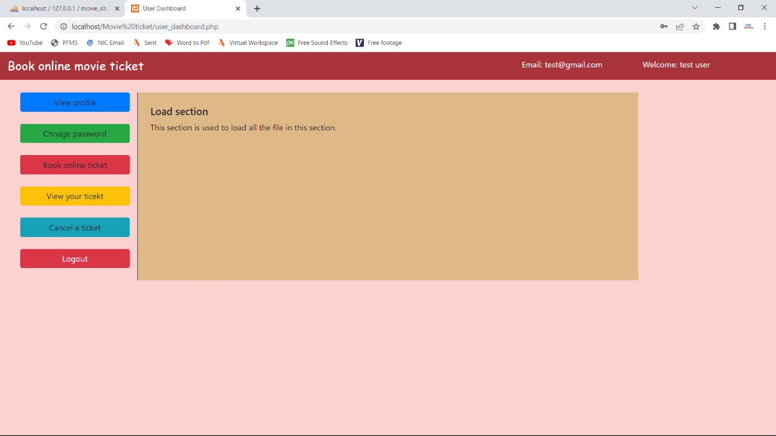

**Update Profile Page :**

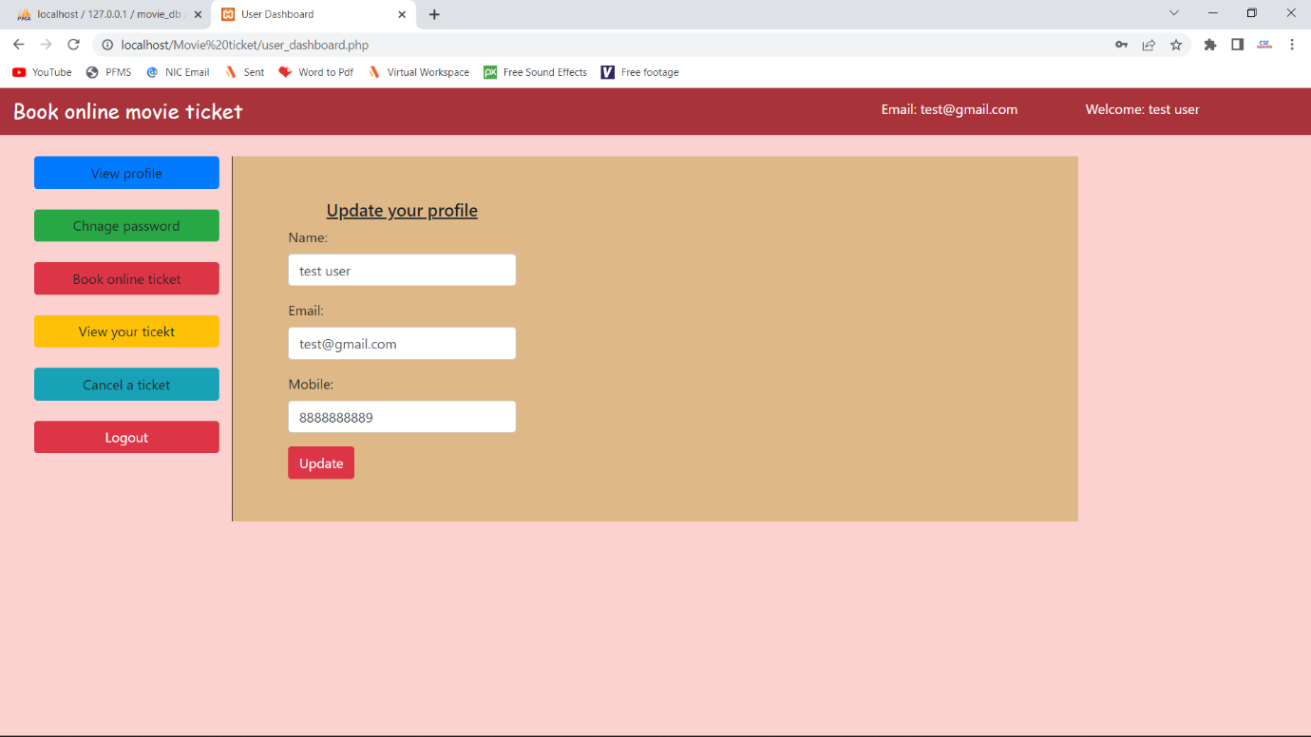

**Book Movie Ticket Page :**

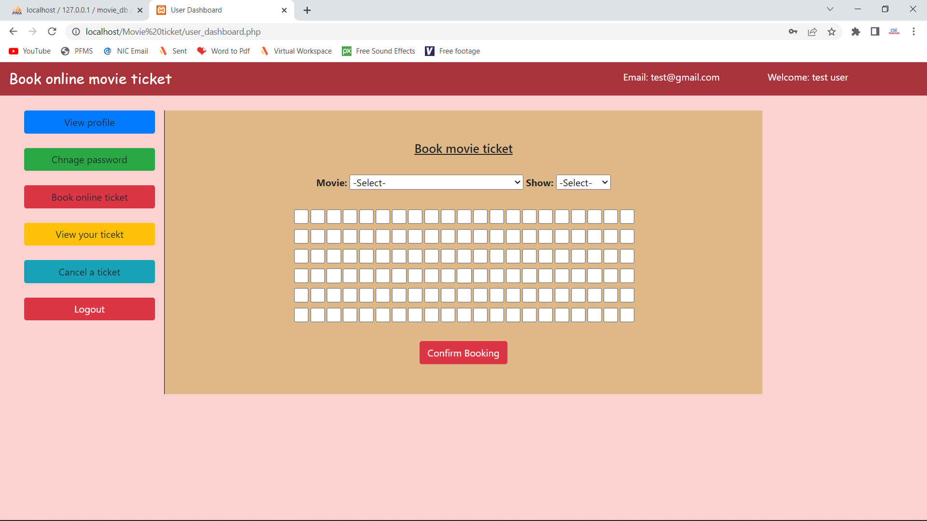

**Cancel Ticket Page :**

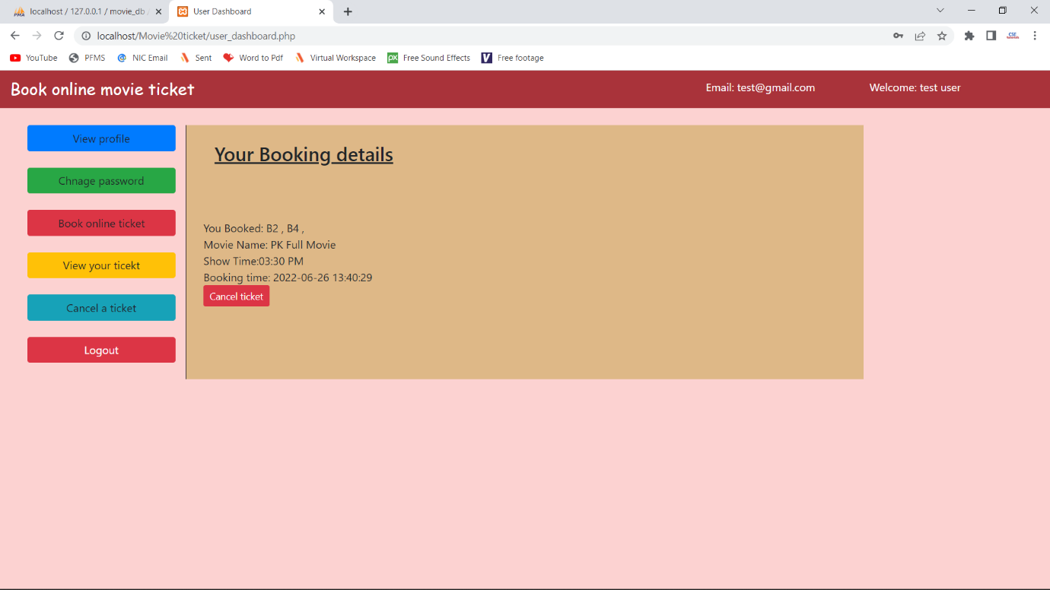

**Admin Dashboard Page :**

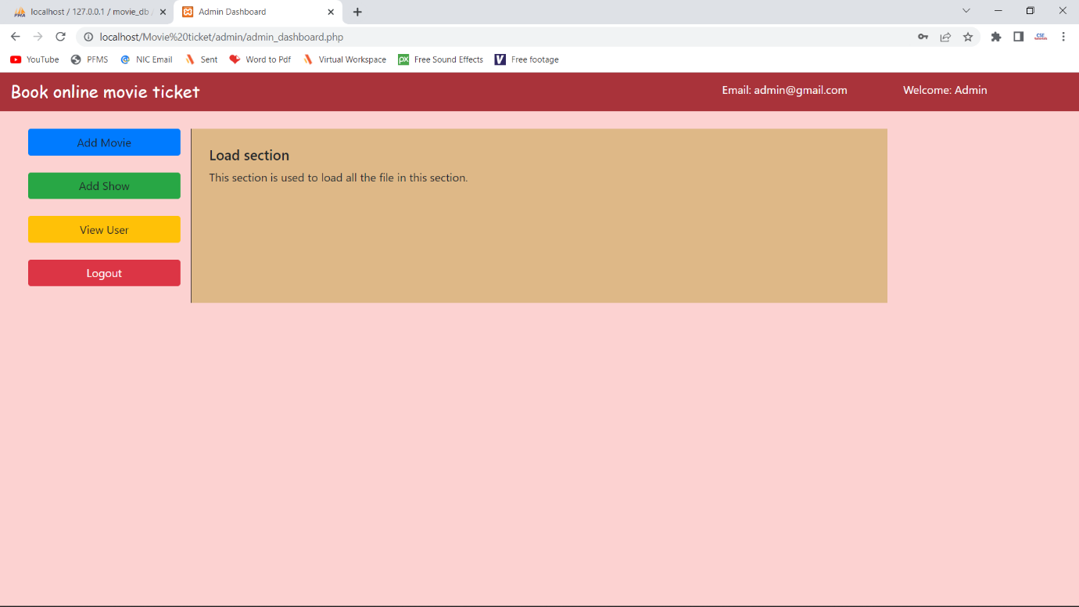

**Add Movie Page** :

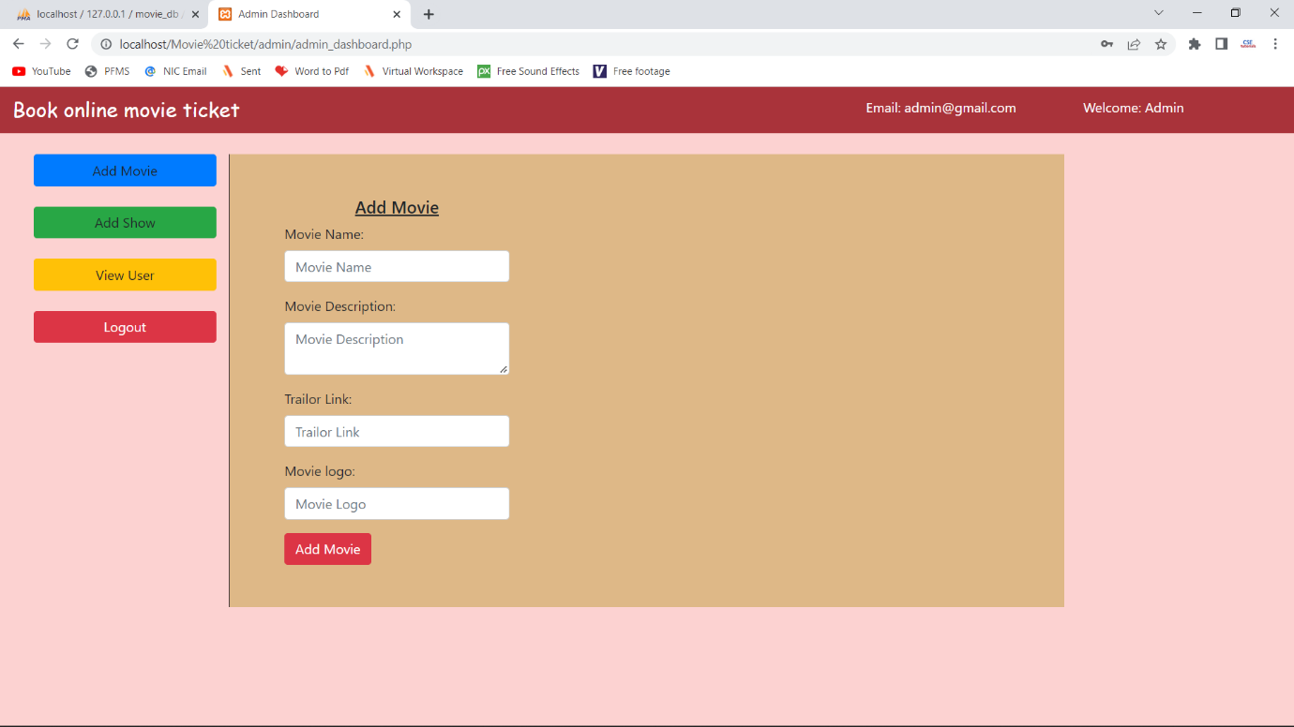

**View/Delete User Page :**

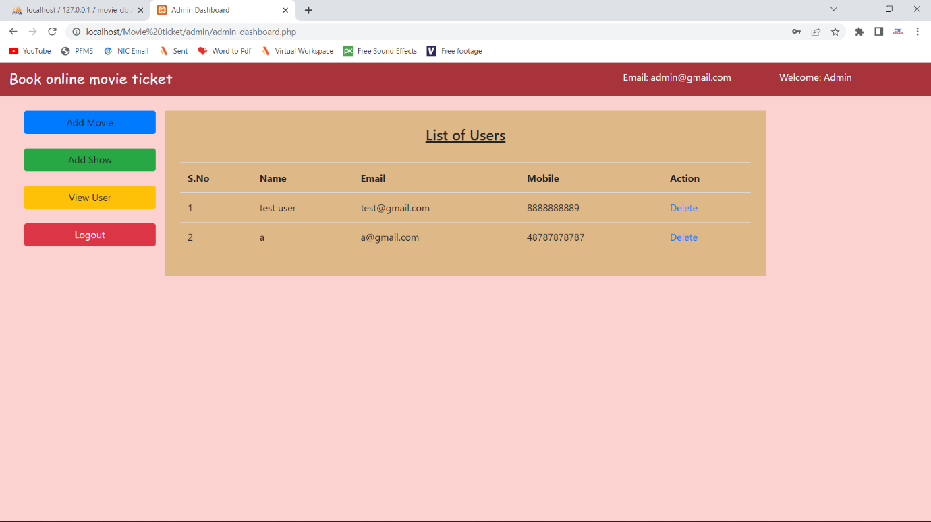

DIAGRAM

**ER Diagram**

**manage**

**Users**

**Admin**

**Book**

**has**

**Booking**

**Movie**

**has**

**Shows**

**Data flow diagram**

**Authentication System**

**Email & password**

**Success or failed**

**Book ticket**

**Query**

**User**

**DB Store**

**User details**

**results**

**Result/Report**

**Manage system**

**Admin**

USE CASE DIAGRAM

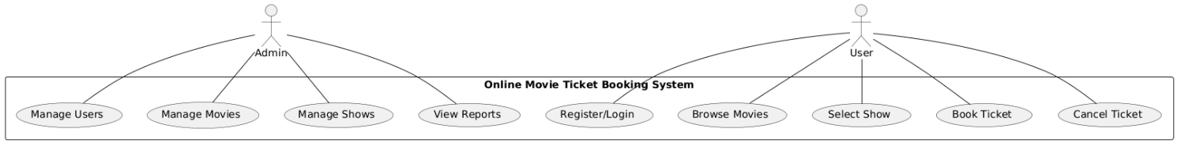

ACTIVITY DIAGRAM

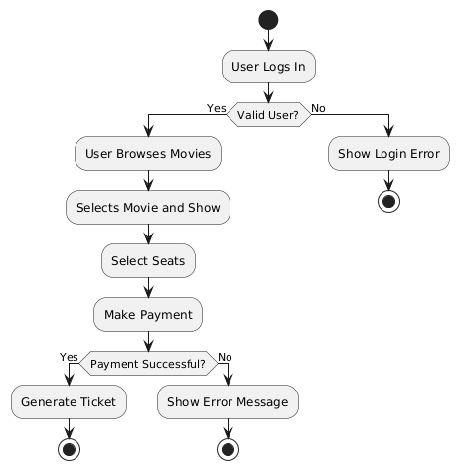

**SEQUENCE DIAGRAM**

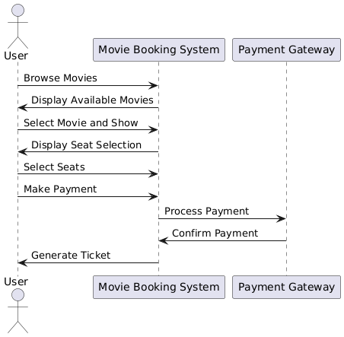

CLASS DIAGRAM

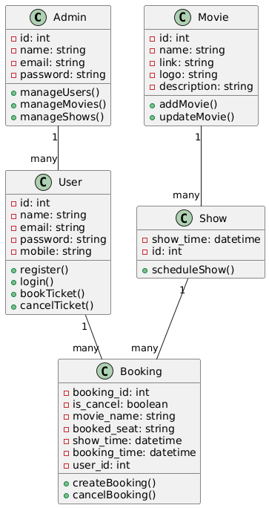

**OUTPUT REPORTS AND TESTING**

**Output Reports:**

1. **User Booking Report – Displays user bookings with movie name, theater, show time, seat numbers, and total price.**
2. **Movie Show Report – Lists all scheduled movie shows with their respective theaters and timings.**
3. **Revenue Report – Shows total earnings based on movie bookings and payment details.**
4. **Seat Availability Report – Displays available and booked seats for each show.**
5. **User Registration Report – Lists all registered users with their details.**

**Testing Approaches:**

1. **Unit Testing – Testing individual modules like user registration, seat selection, and booking confirmation.**
2. **Integration Testing – Ensuring seamless data flow between modules (e.g., from seat selection to payment processing).**
3. **Functional Testing – Verifying that features like booking, cancellation, and ticket generation work correctly.**
4. **Performance Testing – Checking system response time under heavy user load.**
5. **Security Testing – Ensuring data encryption for user credentials and payment details.**

**FUTURE SCOPE**

1. **Mobile Application Integration** – Develop a mobile app for easy ticket booking on Android and iOS.
2. **AI-Based Movie Recommendations** – Implement AI algorithms to suggest movies based on user preferences.
3. **Multiple Payment Gateway Support** – Expand payment options by integrating more gateways like Google Pay, Apple Pay, and Paytm.
4. **Loyalty and Reward System** – Introduce a points-based system to reward frequent users with discounts.
5. **Seat Selection Enhancement** – Improve the graphical interface for a more interactive seat selection experience.
6. **Multi-Theater Chain Support** – Extend the system to support bookings for multiple theater chains.
7. **Live Show Updates and Notifications** – Enable real-time updates on movie availability and send notifications for upcoming shows.
8. **Blockchain-Based Ticket Verification** – Implement blockchain technology for secure and tamper-proof digital ticketing.

**Post Implementation Review**:

1. **SystemPerformance Evaluation – Assess the system’s response time, uptime, and efficiency in handling multiple user requests.**
2. **User Feedback Analysis – Collect and analyze user feedback to identify areas for improvement.**
3. **Security Audit – Review security measures to ensure data protection, preventing unauthorized access and fraud.**
4. **Bug Fixes & Enhancements – Identify and resolve any reported bugs or system issues.**
5. **Scalability Testing – Check if the system can handle increased traffic and expand to multiple theaters.**
6. **User Adoption & Training – Measure how well users (customers and admins) have adapted to the system** and provide necessary training.
7. Financial Review – Evaluate the cost-effectiveness of the system, including maintenance and operational expenses.
8. Future Improvement Plan – Document enhancements and new features to be implemented in future updates.

**CONCLUSION AND RECOMMENDATIONS FOR A MOVIE TICKET BOOKING Website:**

**Conclusion**

The movie ticket booking system successfully automates the process of booking movie tickets online, providing users with a seamless experience. It simplifies ticket reservations, seat selection, and booking confirmation while allowing admins to manage users and track bookings efficiently. The system enhances user convenience by eliminating the need for physical ticket purchases, reducing errors, and streamlining theater operations.

**Recommendations**

1. **Enhance User Experience** – Improve UI/UX with better graphics, real-time seat updates, and an intuitive design.
2. **Mobile Optimization** – Develop a mobile-friendly version or a dedicated mobile app for ease of access.
3. **Add Payment Integration** – Implement secure online payment gateways for a complete transaction process.
4. **Implement Discounts & Offers** – Introduce promotional discounts, loyalty programs, and membership benefits.
5. **Multi-Theater Support** – Expand the system to accommodate multiple theaters with different seat layouts.
6. **Performance Optimization** – Optimize the database and backend to handle high traffic and concurrent bookings.
7. **Security Enhancements** – Strengthen security protocols to prevent fraud, hacking, and data breaches.
8. **Feedback & Review System** – Allow users to rate and review movies and theaters for a better selection process.

By implementing these recommendations, the system can further improve user satisfaction, security, and efficiency, making it a robust and scalable solution for online movie ticket booking.